**Security Council**

**Issue: The question of the Armenian-Azerbaijan conflict over the Nagorno Karabakh territory**

**Geographic Context**

The Nagorno Karabakh territory is located in the South-eastern Lesser Caucasus and encompasses the region between the Lower Karabakh and Syunik. It is part of the greater region of Karabakh and is a landlocked mountainous territory. This region has been home to several conflicts throughout the years and its 1,700 squares miles are now internationally recognized as part of the country of Azerbaijan, however disputes still take place today. Karabakh is the Russian adaptation of an Azeri word which means “black garden”, whilst Nagorno stands for “mountainous” in Russian. [[1]](#footnote-2) The name Artsakh, the denomination the republic of Nagorno Karabakh held for a period of time, means wood in old Armenian, hence, the choice of this word has significant cultural meaning for the Armenian population which proclaimed this Republic through a referendum in 2017.[[2]](#footnote-3)

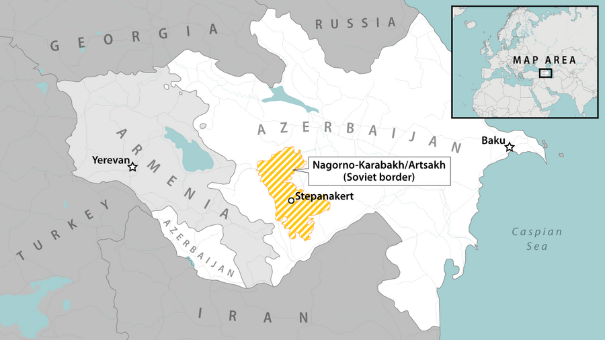[[3]](#footnote-4)

The region was proclaimed to be controlled by the Republic of Artsakh, which was, until 2020, divided into 7 provinces, Lachin District, Qubadli District, Zangilan District, Jabrayil District and Kalbajar District, as well as parts of Agdam, and Fuzuli District. [[4]](#footnote-5) Not all of these districts were integrated as part of Azerbaijan at the same stages, however on an international spectrum they are part of the country, even if there is a current dispute over them, they have not been officially linked to the Armenian government. [[5]](#footnote-6)

The capital of this region is recognized as Stepanakert and its population, according to the BBC’s 2022 figures is of 120,000 people[[6]](#footnote-7), most of whom are ethnically Armenian. Azerbaijan inhabitants and Armenian ones share different religious views, since most Azerbaijanis are Muslims and share very close links to Turkey and house a big ethnically Turkish population, whereas Armenians are mostly Christians who also identify ethnically with the Armenian identity. [[7]](#footnote-8) Such differences have contributed to rising tensions among these different people, and the conflict surrounding this is linked to the pan-Armenian movement of self-determination.

This territory has played a big role when it comes to housing sacred locations across several different religions, which cannot always be proven, due to inaccuracy of historical sources, forcing world leaders to end up claiming this territory as theirs in accordance with their theological beliefs, trapping leaders of both countries in their own rhetoric of argument.[[8]](#footnote-9)

The conflict in this region is of extreme importance to the international community, not only due to its inherent historical value to certain surrounding nations, but also the military and political alliances certain countries hold with both Azerbaijan or Armenia. Furthermore, the humanitarian crisis this conflict has brought, which will be further discussed in this background report, has brought even more attention to the topic, and this includes the arrival of 60,000 to 120,000 people to Armenia which will require resources the country may not be ready to provide, especially due to harsh winter conditions.[[9]](#footnote-10)

**Historical Background**

This ethnic and religious conflict is centuries long and it has provoked historical debate amongst the community as to where the tensions even begun between the people of the region. It is relevant to note that between the 4th and 8th century, the Karabagh region belonged to the Albanian Kingdom. Ziia Buniatov’s 1965 monograph, “Azerbaijan in the Seventh-Ninth Centuries” defends the Azerbaijan people are descendants of the Caucasian Albanians who controlled the area and later converted to Islam.[[10]](#footnote-11)

However, by the 11th century the region was dominated by several different Armenian kingdoms, even though such claim is disputed by Azerbaijani historians. [[11]](#footnote-12) Following this period, the territory was rules by different Turkic and Persian states from the 13th to the 19th century, encompassing the middle age. During such period, both Armenians and Azerbaijanis coexisted peacefully for the most part, despite their ethnic and religious differences.

The Nagorno-Karabakh region falls under Russian control as a result of political and military tensions culminating in the Russo-Persian War which lasted from 1804 to 1813. Thus, under the Treaty of Gulistan[[12]](#footnote-13), Nagorno-Karabakh belonged to Russia and the Treaty of Turkmenchai established the current border between Iran and Azerbaijan. However, in the beginning of the 20th century, during World War I the Ottoman Empire perpetrated a genocide which killed half a million people and led to tens of thousands of Christian Armenians to flee to Russian controlled territories, specifically Nagorno-Karabakh infuriating the relation between Azerbaijanis and Armenians. [[13]](#footnote-14)

The fall of the Russian Empire gave both ethnic groups a short period of independence, spent in considerable tension and conflict over the region. Each ethnic group in the Caucus desired their own national space and thus this was a period of extreme violence. However, the Bolshevik Revolution, even if complex, had sparked within the newfound communist regime, the intention of reoccupying former territories of the Russian Empire which included the independent states of the Caucasus.

In 1922, Armenia Azerbaijan and Georgia formed the Transcaucasian Socialist Federative Soviet Republic[[14]](#footnote-15), where the region of Nagorno-Karabakh was to be included in the Armenian Soviet Socialist Republic (S.S.R.), however, in 1923 Joseph Stalin made this territory an autonomous region within the Azerbaijan S.S.R., disregarding its 94% ethnically Armenian population [[15]](#footnote-16). Protests from the majority Armenian population in the region emerged, however ethnic nationalism wasn’t tolerated and thus the discrimination claimed was ignored.

Soviet rule over the Caucasus region accelerated the desired creation of semi-independent nation and autonomous states where national language and cultures as well as personal identities and passports were preserved. In practice, the Southern region of the Caucasus was a constant overlapping of culture and ethnicities which was not always in alignment with the Soviet national divides.[[16]](#footnote-17)

By 1989, Nagorno-Karabakh's population was approximately 75 percent ethnic Armenian (145,000) and 25 percent ethnic Azeri (40,688).[[17]](#footnote-18) During the late 1980s, tensions in the region intensified. Petitions were raised from ethnic Armenians to be incorporated in its Republic, [[18]](#footnote-19) however such separatist movements were crushed by Azerbaijan. On the 20th of February 1988, the parliament of the Nagorno-Karabakh Autonomous Oblast (NKAO) in Azerbaijan voted to unite the region with Armenia, which resulted in several ethnic cleansings on both ends, such as the Sumgait (1988) and Baku (1990) pogroms directed against Armenians, and the Gugark pogrom (1988) and Khojaly Massacre (1992) directed against Azerbaijanis.

Upon both the Armenian Republic’s independence from the Soviet Union declared on August 30, 1991, and the Azerbaijan Republic’s independence on September 21, 1991, the parliament revoked the autonomous status of Nagorno-Karabakh on November 27, 1991.[[19]](#footnote-20) [[20]](#footnote-21)By this point, the Azerbaijani authorities, with the support of internal forces and the USSR ministry of defense had already started operation “Koltso”, (Ring), which consisted in the deportation of Armenians to border villages. Their actions became more aggressive however, when the first shelling of the capital Stepanakert took place on September 25, 1991 and quickly turned into regular bombings. [[21]](#footnote-22) This was the beginning of the first Nagorno-Karabakh war.

Throughout the war, the Armenian side was able to gain the entire region of Nagorno-Karabakh and the seven surrounding Azerbaijan provinces to it. The capture of Khojali, an Azeri town, right at the beginning of the war, is of great importance as it led to great brutality, with rape, torture cases, 613 habitants killed and another 1,000 injured mostly women, children and elderly. The following captures of towns were also extremely violent. This led to several changes in the Azeri presidency and the capture of the town of Shusha raises the Armenian spirits, especially with the seizure of the Lachin corridor as well. After conquering the northern part of Nagorno-Karabakh, Armenian forces did not struggle to take control over the rest. [[22]](#footnote-23) In 1993, the Security Council fails to pull back Armenia forces from Kelbajar.

Azerbaijan’s internal chaos and lack of political stability contributed to Armenia’s seizure of the entire disputed territory and violent attacks they were able to perpetrate. The war officially ends in May 1994 with the signing of the Bishkek Protocol and a ceasefire begins after diplomatic talks between the two countries which were severely controlled and monitored by Russia.[[23]](#footnote-24)

In December of 1994, the Conference on Security and Cooperation in Europe sent a task force of peacekeepers to the region and deemed the Republic of Armenia, the Republic of Azerbaijan and the Republic of Nagorno-Karabakh had all committed war crimes. However, reports from said task force, revealed the Karabakh Armenian forces with the support of the Republic of Armenia were responsible for the majority of abuses from 1993 to 1994.[[24]](#footnote-25)

Both the Armenians and Azeris were able to coexist in the region during the following near two decades and a half. The region of Nagorno-Karabakh and seven other provinces surrounding the area belonged to Armenia for that time period. Across this time frame, there were occasional fights and skirmishes along the border between the two countries, such as the 4 day conflict in early April of 2016, and tensions did not disappear even though they were considerably easier to manage during those years.[[25]](#footnote-26) There were several attempts at negotiating the peace and the longer it took to reach a compromise, the more frustrated the Azerbaijan government got. The OSCE Minsk Group co-chairs, France, Russia and the USA, were criticized for not pressuring Armenia enough for them to actually retract from occupied Azerbaijani territory. The First Karabakh War was a conflict between Armenia’s attempt at using its army to maintain de facto status over Azerbaijan’s desire to keep de-jure status as per international law. [[26]](#footnote-27)

The bilateral agreement of ceasefire established in 1994 was in place until September of 2020. On the 27th, Azerbaijan launched an offense on the territory following several attacks on the border and successfully broke through the long-standing defence line of the Armenian army and took control of almost two entire south regions (Jabrail and Fizuli) of the five surrounding Nagorno-Karabakh.[[27]](#footnote-28)

Following this attack, there were 6 weeks of intense fighting and displacement in the region, known as the second Nagorno-Karabakh war. There were close to 150 casualties, including 50 civilians in Nagorno-Karabakh and 98 civilian deaths in Azerbaijan. 2,317 soldiers were lost from the Armenian side along with 2,738 on the Azerbaijani front. [[28]](#footnote-29) Fighting ceased on November 10 of 2020, where Armenia, Azerbaijan and Russia agreed on ending the hostilities, after failed attempts from France, the USA and Russia itself.[[29]](#footnote-30)

In early October, over 50,000 residents of Stepanakert had already fled the city to places like Yerevan and Goris. Several NGO’s, such as the Human Rights Watch took action to mitigate the effects of this conflict, regarding not only displaced individuals, but also destroyed infrastructure and striped civilians of basic necessities and essential services.[[30]](#footnote-31) Furthermore, Russian peacekeepers were sent to the area to ensure safety in the region but particularly along the Lachin Corridor. This specific region plays a very important role in this conflict as it is the only highway connecting Armenia and Nagorno-Karabakh which houses 120,000 ethnic Armenians. [[31]](#footnote-32)Armenia agreed to concede all regions of Nagorno-Karabakh that had previously belong to the Soviet Nagorno-Karabakh Autonomous Oblast to Azerbaijan. [[32]](#footnote-33)

The already precarious mediation forces, in specific from the Minsk Group, started to fail in 2022 and the risk of escalation of the conflict became higher especially in light of recent increased militarization on both sides but more significantly, ceasefire violations. On September 13 2022, the biggest provocation since 2020 took place throughout a 2-day conflict which arguably killed between 100 to 300 people[[33]](#footnote-34). This was due to an Azerbaijan perpetrated attack inside Armenian territory, in at least 23 localities along the border. Azerbaijan defended this as a “response to Armenian provocation”. [[34]](#footnote-35)

Although a truce was reached by mediator Russia again, less than a week after, there were several other border clashes.[[35]](#footnote-36) In December of 2022, Azerbaijani environmental activists took control and occupied the Lachin Corridor, to protest against illegal mining in Nagorno-Karabakh. Following this, a blockade was put on the corridor raising international concern, as an action like this can put thousands of lives at risk and is considered a human rights violation.[[36]](#footnote-37) Russian peacekeepers could not reopen the highway (an action backed by the government in Baku) which was being blocked and residents of Nagorno-Karabakh faced shortages and rationing.[[37]](#footnote-38)

In April of 2023, Azerbaijan established checkpoints in the Lachin Corridor under the claim that Armenia was shipping military equipment. Russia’s lack of response to both the blockade and the checkpoint exacerbated the tensions when it comes to the alliance between Armenia and Russia. This action further debilitated Armenian politics and aggravated the humanitarian crisis of the region. [[38]](#footnote-39) Azerbaijan was accused by ethnic Armenians in Nagorno-Karabakh of only intending to block supply and isolating the territory under the false pretext of a protest.[[39]](#footnote-40)

Following this, peace talks were hosted in May of 2023 by Russia, the USA, and the European Union with ministers from both Armenia and Azerbaijan. Armenian Prime Minister Nikol Pashinyan recognized in his speech the territory of Nagorno-Karabakh as part of Azerbaijan. [[40]](#footnote-41)However, he emphasized the importance of Azerbaijan’s acknowledgement of internationally defined borders, from the Soviet era, and the assurance of protection of ethnic Armenians living [[41]](#footnote-42)in Azerbaijan, specifically in of Nagorno-Karabakh and surrounding regions.

This did not eliminate tensions in the region, and there are still attacks happening along the border, fuelling the conflict even more.

**Recent developments**

In September of 2023, there was an agreement to reopen the Lachin Corridor for aid deliveries after nearly 10 months of blockade. [[42]](#footnote-43) However, Azerbaijan launched an offensive in Nagorno Karabakh, as an “anti-terrorist” mission. At least 200 people died [[43]](#footnote-44)over Azerbaijan’s attempt of neutralizing Armenian military operations and their declaration on intending to keep attacking until the surrender of ethnic Armenians.[[44]](#footnote-45)

In just two days Azerbaijan claimed to have taken full control of Nagorno Karabakh[[45]](#footnote-46). However, even though talks of re-integration were beginning to be set up with Russia as a mediator, protests in Yerevan in Armenia were sending the country into a possible political crisis. The government was being accused of not protecting ethnic Armenians and civilians were calling for the resignation of the current Prime Minister Nikol Pashinyan. [[46]](#footnote-47) This prompted thousands of ethnic Armenians to seek safety outside of Nagorno Karabakh.

On the 21st of September 2023, the Security Council met on the issue of the Nagorno Karabakh territory, and the meeting was covered by the UN press in response to a military operation by Baku, Azerbaijan, subsequently followed by an immediate truce, however, it may have set back diplomatic talks currently in place. [[47]](#footnote-48)

This meeting should be taken in consideration by the delegates as a starting point for the debate, and all are strongly encouraged to read it. It is very important to note that developments that took place after this meeting should NOT be taken into account by delegates for the Security Council committee at SPIMUN. This means that the dissolvement of the Nagorno Karabakh Republic in late 2023 and early 2024 will be of no effect for this discussion. Delegates could still of course, familiarise themselves with the development in question by reading the article referenced for this paragraph and perhaps take this as a learning moment and inspiration for their own solutions, although not mandatory or necessary. [[48]](#footnote-49) Delegates should be aware that at this stage of the war, tensions are still extremely high, and the region is facing an extreme humanitarian crisis.

**Relevant Past UN Resolutions & Reports**

* Security Council Resolution 874 - <http://unscr.com/en/resolutions/874> - Pressure to proceed with diplomatic discussions and mediated talks (Minsk Group) (1993)
* Security Council Resolution 884 - <https://digitallibrary.un.org/record/176731?ln=en> – Condemns violations of ceasefire and seeks further diplomatic talks (1994)
* General Assembly Resolution 48/114 – <https://documents.un.org/doc/undoc/gen/n94/149/18/pdf/n9414918.pdf?token=5EHpIVDCxZfjNrapwg&fe=true> Seeks assistance for refugees (1994)
* General Assembly Resolution 62/243 - <https://documents.un.org/doc/undoc/gen/n07/478/35/pdf/n0747835.pdf?token=yGwwcpcpEn85Tw5Pzm&fe=true> – Reaffirms the need for a more peaceful less tense environment and respect for sovereignty over internationally established borders (2008)
* Security Council August 2023 report - <https://www.securitycouncilreport.org/whatsinblue/2023/08/briefing-on-the-situation-in-the-nagorno-karabakh-region.php>
* Parliamentary Assembly of Europe Resolution 2517- <https://pace.coe.int/en/files/33145/html> - humanitarian crisis in Nagorno Karabakh (2023)

**Focus of debate**

Debate on this issue should be focused in responding to the still ongoing violent and military conflicts in the region and reaching a diplomatic solution for the dispute over this territory. While historical background on the issue may be an important point in the discussion, and a central point of arguments, delegates should be focused in finding pro-active solutions that can settle the dispute. Furthermore, delegates are encouraged to delve deeper into the humanitarian crisis and costs this conflict has brought and find ways to mitigate them. The impact of this conflict in the surrounding region is another key point of discussion, as well as the global impact of this issue. Delegates are expected to present clauses that offer viable solutions to questions such as: Who should provide aid for the displaced ethnic Armenian population? How can the blockade of the Lachin Corridor be liaised between the governments of Armenia and Azerbaijan? How can the UN respond to this humanitarian crisis? Which historical claims for this territory have relevance on current-day disputes? How can military offensives be limited? How can border conflicts be mitigated?

**Bloc Positions**

**United States of America:**

The USA condemns Azerbaijan’s recent violent actions towards Armenia and has called for them to cease immediately. The USA has tried to work as a mediator previously for this region but has been unsuccessful in reaching a compromise, however, will still advocate for more diplomatic talks to solve the issue.[[49]](#footnote-50) Furthermore the USA supports the Armenian government’s actions to help displaced individuals who fled Nagorno Karabakh following Azerbaijani occupation find new homes.[[50]](#footnote-51) The USA also advocates for the well-being and safety of all humanitarian workers by sensibilizing both sides of the issue.[[51]](#footnote-52) Lastly, the USA will want to reduce Russian influence in this territory, not only because of its interests on the region and surrounding nations but also to gain more space in diplomatic talks with both the Republic of Azerbaijan, and the Republic of Armenia.[[52]](#footnote-53)

**Russian Federation:**

Russia has played a key role in the conflict since the 1920’s when the Soviet Union began setting borders around this region. More recently however, Russia has been a key mediator in diplomatic talks between Armenia and Azerbaijan and often times the only nation able to reach at least some form of compromise, even if temporary. [[53]](#footnote-54) Russia has shown its discontentment regarding the current prime minister of Armenia and its relations with the country have been getting worse ever since Nikol Pashinyan has been elected. Furthermore, Russia has failed to keep up with their peace keeping duties in the region, particularly in the Lachin Corridor and therefore as put in jeopardy their presence in the Southern Caucasus. [[54]](#footnote-55) Armenia has relied on Russian support and in 2020 was still using Russian arms and strategies from the 1990’s. However with Russia’s passive attitude that offers no protections or solutions for the attacks Armenia has been faced, the country is now looking for security elsewhere. It is important to note Russia will want to keep its presence in the surrounding regions to Nagorno Karabakh.

**Azerbaijan:**

As previously stated, Azerbaijan will not terminate an offensive until Ethnic Armenians have surrendered and agreed to the international borders set for the region by handing over control of Nagorno Karabakh.[[55]](#footnote-56) Azerbaijan’s goal is to neutralize the Armenian miliary forces and take over the territory, which they argue is historically theirs. Azerbaijan wishes to reintegrate the Nagorno Karabakh region into the nation while upholding individual’s rights and disarming the region by ridding it of illegal Armenian Armed Forces.[[56]](#footnote-57)

**Armenia:**

Armenia will appeal to other Nations for protection, arguing has been violated by Azerbaijan offensives with war crimes. Furthermore, they will wish to seek help in removing the blockade imposed of the Lachin Corridor and protect the Ethnic Armenians living in Nagorno Karabakh, as well as the ones who have fled the region following Azerbaijan’s violent attacks.[[57]](#footnote-58) Moreover, Armenia’s goal is to be able to provide basic needs to its population as well as the one living in in Nagorno Karabakh in light of the Lachin Corridor’s blockade which has cut supply. Armenia’s priority is not the control over Nagorno Karabakh but rather “security and rights guarantees” for those who live there.[[58]](#footnote-59)

**Additional maps and graphics:**

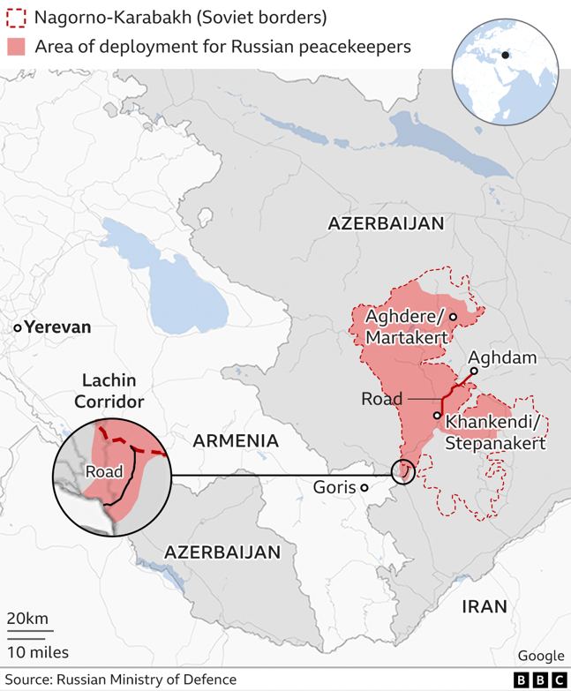

Map 1 - Nagorno Karabakh as of 2023 (BBC)

Map 2 Casualty Data between September of 2020 and September of 2023 (Crisis Group) [[59]](#footnote-60)

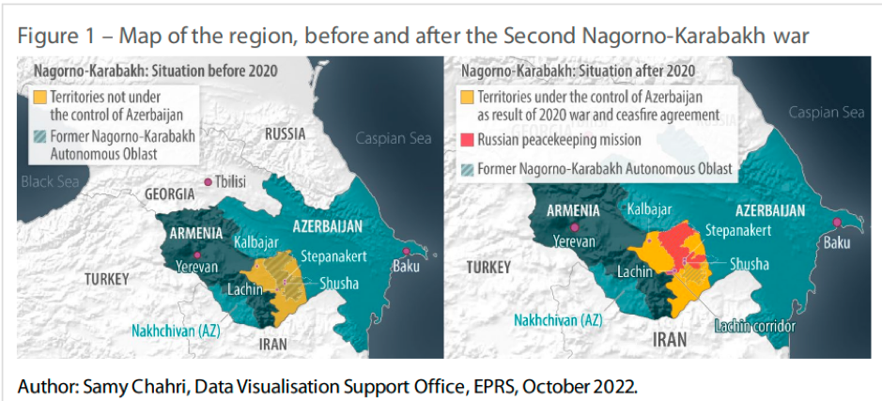

Map 3- Impact of the Second Nagorno-Karabakh war (The European Conservative)[[60]](#footnote-61)

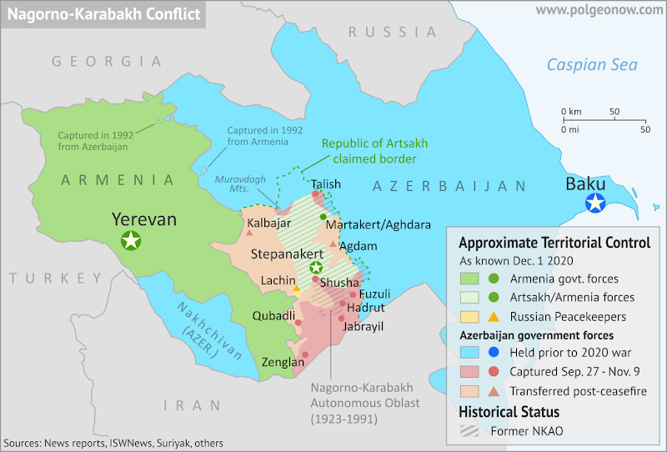

Map 4 – Regions within Nagorno-Karabakh as of December of 2020 (Polgeonow)[[61]](#footnote-62)

Map 5 - Nagorno-Karabakh’s Seven districts as of 1991 to 1994 (Nationalista)[[62]](#footnote-63)

1. <https://www.bbc.com/news/world-europe-18270325> [↑](#footnote-ref-2)
2. <http://www.nkrusa.org/country_profile/history.shtml> [↑](#footnote-ref-3)
3. <https://www.csmonitor.com/World/Europe/2023/0919/With-world-distracted-Azerbaijan-tries-to-stamp-out-Karabakh-separatists> [↑](#footnote-ref-4)
4. <https://jam-news.net/karabakh-war-seven-occupied-regions-azerbaijan-armenia-shahin-rzayev-commentary-news/> [↑](#footnote-ref-5)
5. <https://www.aljazeera.com/news/2023/4/24/explainer-what-is-nagorno-karabakh-why-are-tensions-rising> [↑](#footnote-ref-6)
6. <https://www.bbc.co.uk/news/world-europe-18270325> [↑](#footnote-ref-7)
7. <https://www.trtworld.com/magazine/why-azerbaijanis-and-armenians-have-been-fighting-for-so-long-38163> [↑](#footnote-ref-8)
8. [https://neweasterneurope.eu/2020/04/14/why-nagorno-karabakh-matters/#\_ftn2](https://neweasterneurope.eu/2020/04/14/why-nagorno-karabakh-matters/" \l "_ftn2) [↑](#footnote-ref-9)
9. <https://carnegie-mec.org/diwan/90670> [↑](#footnote-ref-10)
10. <https://src-h.slav.hokudai.ac.jp/coe21/publish/no18/3_yoshimura.pdf> [↑](#footnote-ref-11)
11. <https://dergipark.org.tr/tr/download/article-file/228073> [↑](#footnote-ref-12)
12. <https://www.britannica.com/topic/Treaty-of-Golestan> [↑](#footnote-ref-13)
13. <https://meduza.io/en/feature/2020/10/01/why-nagorno-karabakh> [↑](#footnote-ref-14)
14. <https://www.dw.com/en/whats-behind-the-conflict-over-nagorno-karabakh/a-66951971> [↑](#footnote-ref-15)
15. <https://www.nationalgeographic.com/premium/article/nagorno-karabakh-armenia-azerbaijan-conflict-geography-ussr> [↑](#footnote-ref-16)
16. <https://www.historytoday.com/miscellanies/nagorno-karabakhs-myth-ancient-hatreds> [↑](#footnote-ref-17)
17. <https://www.hrw.org/reports/AZER%20Conflict%20in%20N-K%20Dec94_0.pdf> [↑](#footnote-ref-18)
18. <https://www.cfr.org/global-conflict-tracker/conflict/nagorno-karabakh-conflict> [↑](#footnote-ref-19)
19. <https://uca.edu/politicalscience/home/research-projects/dadm-project/europerussiacentral-asia-region/azerbaijannagorno-karabakh-1991-present/> [↑](#footnote-ref-20)
20. <https://www.nkr.am/en/independence-referendum-in-karabakh> [↑](#footnote-ref-21)
21. <https://www.nkr.am/en/azerbaijani-aggression> [↑](#footnote-ref-22)
22. <https://ifsh.de/file-CORE/documents/yearbook/english/04/Souleimanov.pdf> [↑](#footnote-ref-23)
23. <https://www.rferl.org/a/1065626.html> [↑](#footnote-ref-24)
24. <https://www.hrw.org/report/1994/12/01/seven-years-conflict-nagorno-karabakh> [↑](#footnote-ref-25)
25. <https://reliefweb.int/report/armenia/getting-ceasefire-peace-nagorno-karabakh> [↑](#footnote-ref-26)
26. <https://blog.prif.org/2020/11/05/nagorno-karabakh-why-the-second-armenia-azerbaijan-war-started/> [↑](#footnote-ref-27)
27. <https://jam-news.net/karabakh-war-seven-occupied-regions-azerbaijan-armenia-shahin-rzayev-commentary-news/> [↑](#footnote-ref-28)
28. <https://reliefweb.int/report/azerbaijan/azerbaijan-pre-existing-situation-and-impact-2020-nagorno-karabakh-conflict-21> [↑](#footnote-ref-29)
29. [https://www.cfr.org/global-conflict-tracker/conflict/nagorno-karabakh-conflict#:~:text=After%20several%20failed%20attempts%20by,week%20Second%20Nagorno%2DKarabakh%20War](https://www.cfr.org/global-conflict-tracker/conflict/nagorno-karabakh-conflict" \l ":~:text=After%20several%20failed%20attempts%20by,week%20Second%20Nagorno%2DKarabakh%20War). [↑](#footnote-ref-30)
30. <https://www.hrw.org/news/2020/12/11/azerbaijan-unlawful-strikes-nagorno-karabakh> [↑](#footnote-ref-31)
31. <https://www.aljazeera.com/news/2023/9/20/whats-happening-in-nagorno-karabakh-between-azerbaijan-and-armenia> [↑](#footnote-ref-32)
32. <https://www.bbc.com/news/world-europe-18270325> [↑](#footnote-ref-33)
33. <https://www.cfr.org/global-conflict-tracker/conflict/nagorno-karabakh-conflict> [↑](#footnote-ref-34)
34. <https://oc-media.org/features/explainer-what-happened-in-armenia-and-azerbaijan-on-13-14-september/> [↑](#footnote-ref-35)
35. <https://www.reuters.com/world/asia-pacific/un-hopes-armenia-azerbaijan-ceasefire-holds-2022-09-15/> [↑](#footnote-ref-36)
36. <https://www.amnesty.org/en/latest/news/2023/02/azerbaijan-blockade-of-lachin-corridor-putting-thousands-of-lives-in-peril-must-be-immediately-lifted/> [↑](#footnote-ref-37)
37. <https://www.bbc.com/news/world-europe-64174164> [↑](#footnote-ref-38)
38. <https://www.eiu.com/n/azerbaijan-sets-up-checkpoints-on-the-lachin-corridor/> [↑](#footnote-ref-39)
39. <https://www.rferl.org/a/armenia-azerbaijan-lachin-checkpoints/32375862.html> [↑](#footnote-ref-40)
40. <https://www.primeminister.am/hy/statements-and-messages/item/2023/04/18/Nikol-Pashinyan-Speech/> [↑](#footnote-ref-41)
41. <https://www.politico.eu/article/armenia-vow-recognize-azerbaijan-nagorno-karabakh-tensions/> [↑](#footnote-ref-42)
42. <https://www.cfr.org/in-brief/azerbaijans-pressure-nagorno-karabakh-what-know> [↑](#footnote-ref-43)
43. <https://edition.cnn.com/2023/09/19/asia/armenia-azerbaijan-nagorno-karabakh-bombardment-intl/index.html> [↑](#footnote-ref-44)
44. <https://www.bbc.com/news/world-europe-66851975> [↑](#footnote-ref-45)
45. <https://apnews.com/article/azerbaijan-armenia-explosions-nagorno-karabakh-russia-2964483a95121dfdccd0e6e4d220fb12> [↑](#footnote-ref-46)
46. <https://www.bbc.com/news/world-europe-66870061> [↑](#footnote-ref-47)
47. <https://press.un.org/en/2023/sc15418.doc.htm> [↑](#footnote-ref-48)
48. <https://www.hrw.org/world-report/2024/country-chapters/armenia> [↑](#footnote-ref-49)
49. [https://www.state.gov/call-for-end-of-hostilities-in-nagorno-karabakh/#:~:text=The%20United%20States%20is%20deeply,to%20cease%20these%20actions%20immediately](https://www.state.gov/call-for-end-of-hostilities-in-nagorno-karabakh/" \l ":~:text=The%20United%20States%20is%20deeply,to%20cease%20these%20actions%20immediately). [↑](#footnote-ref-50)
50. <https://osce.usmission.gov/the-situation-in-and-around-nagorno-karabakh/> [↑](#footnote-ref-51)
51. <https://osce.usmission.gov/on-the-situation-in-nagorno-karabakh-2/> [↑](#footnote-ref-52)
52. <https://www.brookings.edu/articles/a-new-caucasus-conflict-tests-the-limits-of-us-power/> [↑](#footnote-ref-53)
53. <https://www.cfr.org/global-conflict-tracker/conflict/nagorno-karabakh-conflict> [↑](#footnote-ref-54)
54. <https://carnegieendowment.org/politika/90768> [↑](#footnote-ref-55)
55. <https://www.bbc.com/news/world-europe-66851975> [↑](#footnote-ref-56)
56. <https://www.france24.com/en/live-news/20231003-what-are-azerbaijan-s-plans-for-nagorno-karabakh> [↑](#footnote-ref-57)
57. <https://www.aljazeera.com/news/2023/9/22/what-lies-ahead-for-the-armenians-of-nagorno-karabakh> [↑](#footnote-ref-58)
58. <https://carnegieendowment.org/politika/89635> [↑](#footnote-ref-59)
59. <https://www.crisisgroup.org/content/nagorno-karabakh-conflict-visual-explainer> [↑](#footnote-ref-60)
60. <https://europeanconservative.com/articles/news/no-sanctions-against-azerbaijan-blockade-of-lachin-corridor-continues/> [↑](#footnote-ref-61)
61. <https://www.polgeonow.com/2020/12/nagorno-karabakh-control-map-after-ceasefire-withdrawals.html> [↑](#footnote-ref-62)
62. <https://www.nationalia.info/new/11335/karabakh-commemorates-independence-day-as-threat-of-azerbaijani-attack-continues-to-haunt-> [↑](#footnote-ref-63)